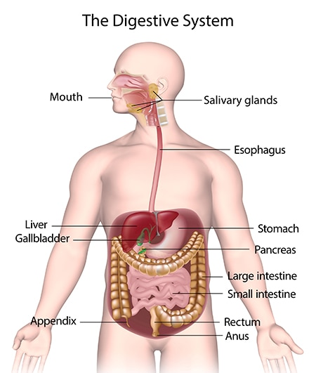

This Is a diagram of the whole digestive system inside the human body. **(and, 2023)**

**Mouth and Oesophagus:**

Digestion begins in the mouth where the food enters our body through ingestion and where mechanical digestion begins, then the chicken breast is mechanically chewed from our teeth , mainly incisors and canines which help biting and tearing the meat, and our molars for grinding and chewing into small pieces which help on making it easier for our body to digest the chicken breast, this is a process called mastication and then the chicken breast is chemically mixed with saliva inside our mouth to lubricate the food, which is produced in the salivary glands. Saliva contains enzymes, primarily amylase which play a role in breaking down starches and complex carbohydrates in the bread into simple sugars (glucose mainly) that your body can absorb easily. This initiates chemical digestion**. (Ifeanyichukwu Ogobuiro et al., 2022).**

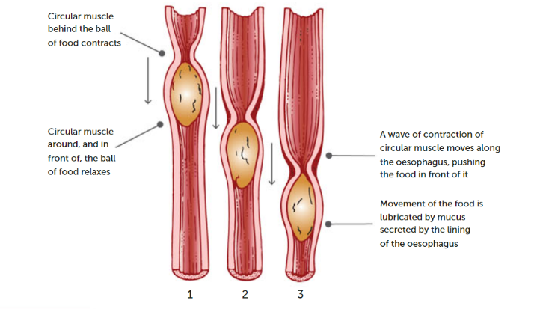When we swallow the chicken breast and saliva combination after it’s been broken down in our mouth and formed into a bolus from our tongue, and pushed to the epiglottis which covers the larynx when swallowing to prevent the bolus from entering our trachea. The epiglottis shuts the entrance to the trachea to prevent food from entering our respiratory system. Rather, the epiglottis directs and pushes food towards the oesophagus which is a muscular tube that connects the mouth to the stomach, and where muscle contractions squeeze the bolus through its tract, this process is called peristalsis. The chicken breast will only spend at max 10-30 seconds inside our mouth depending on the quantity and around 3-10 seconds in the oesophagus. **(*LibGuides: BIO 140 - Human Biology I - Textbook: Chapter 16 - Digestive System Processes and Regulation*, 2013)**

In the diagram, the food is being pushed along the esophagus and along the rest of the alimentary canal by the process called peristalsis. **(2023)**

**Stomach:**

Both the mechanical and chemical digestion of chicken breasts rely heavily on the stomach. Strong muscular contractions of the stomach walls mix and grind the chicken breast into even smaller particles, making it easier to chemically digest. **(And, 2023)**. Gastric juice, which contains hydrochloric acid and enzymes like pepsin, and the food that has been ingested are mechanically combined and crushed into a semi-liquid substance called chyme. Enzymes such aspepsin which breaks down proteins from the chicken breast into amino acids which makes it easier for the food to be absorbed into the body through the bloodstream. Chicken Breast usually stays inside the stomach around 30-140 minutes, depending on the individual’s metabolism. **(*The Stomach and Its Role in Digestion | Laparoscopic.MD*, 2023)**

This image shown above is a imagine of the stomach and all the functions if carries out. **(2023)**

**Small Intestine (Breakdown):**

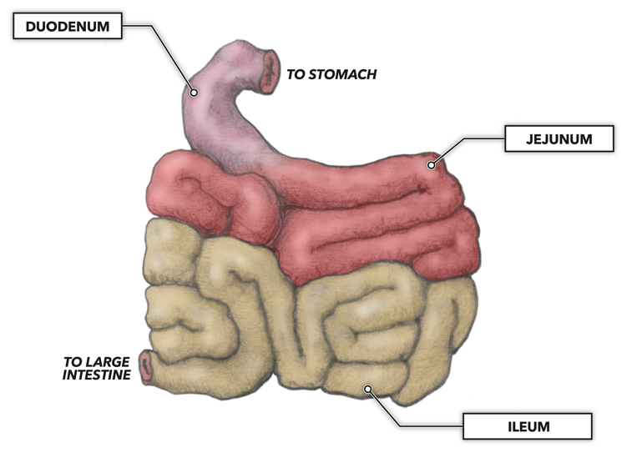After leaving the stomach, the chyme enters the first part of the small intestine, the duodenum. Here pancreatic juices, made by the pancreas, and bile which is make from the liver and stored in the gall bladder. Both are taken into the small intestine and mixed with the chyme. In order to further break down proteins, lipids, and carbohydrates into smaller molecules that are potentially absorbed by the intestinal wall, the pancreas and gall bladder both secrete enzymes and bile all through this process. **(and, 2023).** Amino acids are created when proteins are broken down and are then utilised by the body for a wide range of processes, including the synthesis of new proteins and tissue maintenance. Fatty acids and glycerol, which can be used for the production of energy or stored in adipose tissue, are produced when fats are broken down. Glucose, the body's main energy source, is produced when carbohydrates are broken down. The watery chyme moves into the part of the small intestine called the jejunum and then the ileum where most of the absorption of water and nutrients; glucose and amino acids, takes place. **(*Digestive System Processes and Regulation | Anatomy and Physiology II*, 2023)**

The photo above shows All the parts of the small intestine**. (Lakna, 2020)**

**Small intestine (Absorption)**

At this stage, digestion is completed. The lining of the small intestine is covered with finger-like projections called villi, which contain even smaller projections called microvilli. These features increase the small intestine's surface area, allowing effective absorption of nutrients. Through both passive and active transport processes, the nutrients are absorbed. Multiple processes are used to transport different nutrients, for example, fatty acids are transported passively while glucose and amino acids are transported actively. The body distributes all the nutrients after they pass through capillaries and through the bloodstream. Any substances that the small intestine has failed to absorb are sent into the big intestine. The chyme will stay in the small intestine for usually 2 to 6 hours. **(*Digestive System Processes and Regulation | Anatomy and Physiology II*, 2023)**

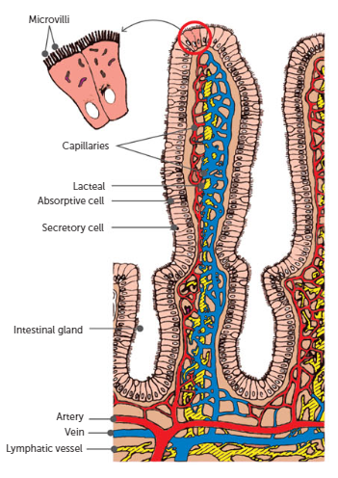

This is the structure of the Villus. **(2023)**

**Material Breakdown and Use**

Throughout the digestive process, chicken breast is broken down into a number of various substances. Amino acids, which are produced from the breakdown of proteins, are essential for the synthesis of new proteins and for the maintenance of tissues. Fatty acids and glycerol, which can be used for the production of energy or stored in adipose tissue, are produced when fats are broken down. Glucose, the body's main energy source, is produced when carbohydrates are broken down or carbohydrates can be stored as glycogen in the liver and muscles. In addition to these macronutrients, chicken breast also contains vitamins and minerals that are important in a number of physiological processes, such as iron and vitamin B12. **(Health, 2014)**

**Large intestine:**

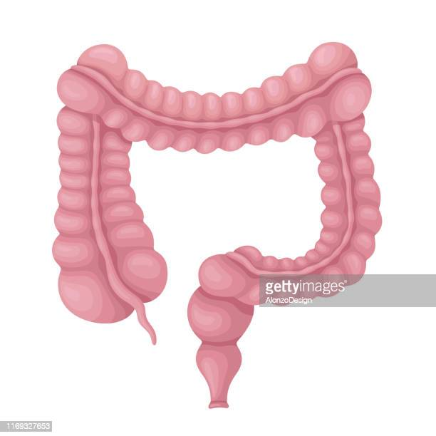Water is reabsorbed as particles that remain move through the large intestine, helping in the formation of solid faeces. In addition, the large intestine absorbs minerals including salt, potassium, and chloride, which are crucial for maintaining the body's fluid balance. On top of that, several vitamins, including vitamin K and the B vitamins, are made by bacteria in the colon and absorbed into the bloodstream.

Colon bacteria have an important role in breaking down substances that were not digested in the small intestine. They breakdown fibres and other difficult-to-digest carbohydrates, creating short-chain fatty acids that can be converted into energy. Gases like methane and hydrogen are produced by bacteria in the colon and can leave the body through flatulence. The waste material will spend around 15-60 hours inside the large intestine before leaving the body. **(*Colon (Large Intestine): Function, Anatomy & Definition*, 2021)**

This Is a photo of the large intestine inside the human body. **(Large, 2019)**

**Elimination and faeces:**

Elimination is the final stage of the digestive process. In this stage, the compressed waste is sent from the large intestine to the rectum as faeces. The end part of the large intestine, known as the rectum, is where faeces are kept until they leave the body through the anus, the external opening at the end of the rectum. Unabsorbed water, undigested food, bacteria, leftover bile components, and cellular waste make up faeces. **(*Bowel Movement*, 2015)**

**REFRENCES:**

*Digestive System : Introduction | BIO103: Human Biology*. (2016). Lumenlearning.com. <https://courses.lumenlearning.com/suny-dutchess-ap1/chapter/digestive-system/>

‌ Ifeanyichukwu Ogobuiro, Gonzales, J., & Tuma, F. (2022, April 21). *Physiology, Gastrointestinal*. Nih.gov; StatPearls Publishing. <https://www.ncbi.nlm.nih.gov/books/NBK537103/#:~:text=The%20function%20of%20the%20digestive,%2C%20large%20intestine%2C%20and%20rectum>.

*LibGuides: BIO 140 - Human Biology I - Textbook: Chapter 16 - Digestive System Processes and Regulation*. (2013). Cuny.edu. <https://guides.hostos.cuny.edu/bio140/5-16#:~:text=Figure%202%3A%20The%20digestive%20processes,for%20example%2C%20alcohol%20and%20aspirin>.

(2023). Nelsonnet.com.au. <https://ebooks.nelsonnet.com.au/wr/viewer.html?subscriptionId=48f356a8-2c96-45f7-a7a6-daa5c468c928#book/32104c80-2d58-4ca3-b235-55f673633a34/page_000146.xhtml>

‌ and, D. (2023, May 3). *Your Digestive System & How it Works*. National Institute of Diabetes and Digestive and Kidney Diseases; NIDDK - National Institute of Diabetes and Digestive and Kidney Diseases. <https://www.niddk.nih.gov/health-information/digestive-diseases/digestive-system-how-it-works>

‌ *The Stomach and Its Role in Digestion | Laparoscopic.MD*. (2023). Laparoscopic.md. <https://www.laparoscopic.md/digestion/stomach>

‌ *Digestive System Processes and Regulation | Anatomy and Physiology II*. (2023). Lumenlearning.com. <https://courses.lumenlearning.com/suny-ap2/chapter/digestive-system-processes-and-regulation/#:~:text=The%20digestive%20processes%20are%20ingestion,for%20example%2C%20alcohol%20and%20aspirin>.

‌ *The Small Intestine | Complete Anatomy*. (2019, November 22). Complete Anatomy | Advanced 3D Anatomy Platform; 3D4Medical. <https://3d4medical.com/blog/small-intestine>

Health. (2014). *Digestive system*. Vic.gov.au. <https://www.betterhealth.vic.gov.au/health/conditionsandtreatments/digestive-system>

and, D. (2023, May 6). *Your Digestive System & How it Works*. National Institute of Diabetes and Digestive and Kidney Diseases; NIDDK - National Institute of Diabetes and Digestive and Kidney Diseases. <https://www.niddk.nih.gov/health-information/digestive-diseases/digestive-system-how-it-works>

‌Lakna. (2020, January 2). *What is the Difference Between Villi and Microvilli - Pediaa.com*. Pediaa.com. <https://pediaa.com/what-is-the-difference-between-villi-and-microvilli/>

‌ Large. (2019). *Large Intestine Photos and Premium High Res Pictures - Getty Images*. Gettyimages.com.au. <https://www.gettyimages.com.au/photos/large-intestine>

*Colon (Large Intestine): Function, Anatomy & Definition*. (2021). Cleveland Clinic. <https://my.clevelandclinic.org/health/body/22134-colon-large-intestine>

‌ *Bowel Movement*. (2015). Medlineplus.gov; National Library of Medicine. <https://medlineplus.gov/bowelmovement.html#:~:text=Your%20stool%20passes%20out%20of,what%20you%20eat%20and%20drink>.